JAVA PROJECT SEM III

PROJECT REPORT
On

CAMPUS CONNECT
A Student Event Management System

By
GROUP NO: 6

NEKHAL JAMES
ASHIQUE P JO
NANDHANA S
GAYATHRI BHADRA R

1. Introduction
1.1 Purpose
This document provides a comprehensive overview of the CampusConnect project, a desktop application designed to facilitate event organization and community engagement within college environments. It details the project's objectives, requirements, design, implementation details, user guidance, and testing procedures.
1.2 Scope
CampusConnect is a standalone Java Swing application enabling students, event organizers, and administrators to manage college events. Key functionalities include user authentication, role-based access, event creation and management, student registration, feedback collection, and participant viewing. The application utilizes a local SQLite database for data persistence.

2. Objectives
The primary objectives of the CampusConnect project are:
- To provide a centralized platform for managing college events.
- To streamline the event registration process for students.
- To enable event organizers to efficiently create, manage, and track their events.
- To facilitate feedback collection for continuous improvement of events.
- To offer distinct functionalities based on user roles (Student, Organizer, Admin).
- To ensure a secure, reliable, and user-friendly experience through a well-designed desktop application adhering to SOLID principles.

3. Requirement Specification
3.1 Hardware Requirements
- Platform: Standard PC (Windows, macOS, Linux) with Java compatibility.
- Input Devices: Keyboard and Mouse.
- Memory: Minimum 4GB RAM.
- Storage: Minimum 100MB disk space for the application and database.
- Display: Minimum resolution of 1024x768.

3.2 Software Requirements
- Operating System: Windows, macOS, or Linux.
- Runtime Environment: Java Runtime Environment (JRE) 17 or higher.
- Database: SQLite (managed via JDBC).
- Build Tool: Apache Maven (for dependency management and building).
- Libraries:
  - SQLite JDBC Driver (org.xerial:sqlite-jdbc)
  - JUnit 5 (for testing - org.junit.jupiter:junit-jupiter-api, org.junit.jupiter:junit-jupiter-engine)

4. Design Document
4.1 Class Diagram
The application follows a Layered Architecture incorporating the Model-View-Controller (MVC) pattern and SOLID principles. The main layers are UI, Service, Repository, Model, and Utility.
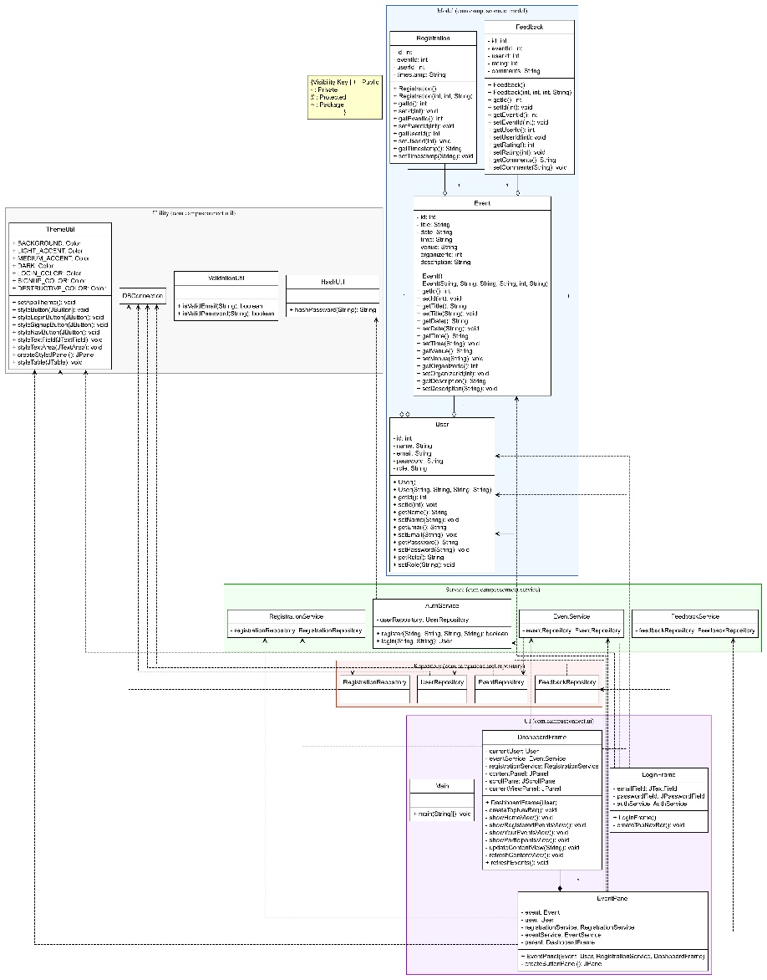
4.2 Database Design
The application uses a local SQLite database named campusconnect.db. The schema consists of four main tables: users, events, registrations, and feedback. Foreign keys enforce relationships between these tables.
(SQL Schema):
-- Users table: Stores user information including credentials and role.
CREATE TABLE IF NOT EXISTS users (
id INTEGER PRIMARY KEY AUTOINCREMENT,
name TEXT NOT NULL,
email TEXT UNIQUE NOT NULL,
password TEXT NOT NULL, -- Stored as SHA-256 hash
role TEXT NOT NULL CHECK(role IN ('Student', 'Organizer', 'Admin'))
);

-- Events table: Stores details about each event.
CREATE TABLE IF NOT EXISTS events (
id INTEGER PRIMARY KEY AUTOINCREMENT,
title TEXT NOT NULL,
date TEXT NOT NULL, -- Format: YYYY-MM-DD
time TEXT NOT NULL, -- Format: HH:MM
venue TEXT NOT NULL,
organizer_id INTEGER, -- Foreign key referencing users table
description TEXT,
FOREIGN KEY (organizer_id) REFERENCES users(id) ON DELETE SET NULL -- Or ON DELETE CASCADE if events should be deleted if organizer is deleted
);

-- Registrations table: Tracks which users are registered for which events.
CREATE TABLE IF NOT EXISTS registrations (
id INTEGER PRIMARY KEY AUTOINCREMENT,
event_id INTEGER, -- Foreign key referencing events table
user_id INTEGER, -- Foreign key referencing users table
timestamp TEXT, -- Time of registration
FOREIGN KEY (event_id) REFERENCES events(id) ON DELETE CASCADE, -- If event is deleted, remove registrations
FOREIGN KEY (user_id) REFERENCES users(id) ON DELETE CASCADE, -- If user is deleted, remove registrations
UNIQUE(event_id, user_id) -- Prevent duplicate registrations
);

-- Feedback table: Stores user feedback for specific events.
CREATE TABLE IF NOT EXISTS feedback (
id INTEGER PRIMARY KEY AUTOINCREMENT,
event_id INTEGER, -- Foreign key referencing events table
user_id INTEGER, -- Foreign key referencing users table
rating INTEGER CHECK(rating >= 1 AND rating <= 5), -- Rating from 1 to 5
comments TEXT,
FOREIGN KEY (event_id) REFERENCES events(id) ON DELETE CASCADE,
FOREIGN KEY (user_id) REFERENCES users(id) ON DELETE CASCADE,
UNIQUE(event_id, user_id) -- Allow only one feedback per user per event
);

-- Enable foreign key support in SQLite
PRAGMA foreign_keys = ON;

5. Source Code
The source code is organized into packages following standard Java conventions (com.campusconnect.main, com.campusconnect.model, com.campusconnect.repository, com.campusconnect.service, com.campusconnect.ui, com.campusconnect.util).
GitHub - https://github.com/Nekhal-james/CampusConnect
Main Application – CampusConnectApp.java
package main;
import views.LoginView;
public class CampusConnectApp {
public static void main(String[] args) {
javax.swing.SwingUtilities.invokeLater(() -> {
new LoginView().setVisible(true);
});
}
}
Explanation:
* The program starts execution from the main() method.
* The SwingUtilities.invokeLater() method ensures that the graphical interface runs smoothly on the Event Dispatch Thread (EDT).
* The LoginView window is the first interface shown to the user.

Model Classes (Data Layer)
User.java
package models;
public class User {
private int userId;
private String name;
private String email;
private String password;
private String role;
public User(int userId, String name, String email, String password, String role) {
this.userId = userId;
this.name = name;
this.email = email;
this.password = password;
this.role = role;
}
public int getUserId() { return userId; }
public String getName() { return name; }
public String getEmail() { return email; }
public String getRole() { return role; }
public void setPassword(String password) { this.password = password; }
}
Purpose:
Defines user profiles and supports authentication and role management.

Event.java
package models;
import java.time.LocalDate;
public class Event {
private int eventId;
private String title;
private String description;
private LocalDate date;
private String location;
private int organizerId;
public Event(int eventId, String title, String description, LocalDate date, String location, int organizerId) {
this.eventId = eventId;
this.title = title;
this.description = description;
this.date = date;
this.location = location;
this.organizerId = organizerId;
}
public int getEventId() { return eventId; }
public String getTitle() { return title; }
public String getDescription() { return description; }
public LocalDate getDate() { return date; }
public String getLocation() { return location; }
public int getOrganizerId() { return organizerId; }
}
Purpose:
Stores and manages event details such as title, description, and schedule information.

Registration.java
package models;
public class Registration {
private int regId;
private int eventId;
private int studentId;
private String status;
public Registration(int regId, int eventId, int studentId, String status) {
this.regId = regId;
this.eventId = eventId;
this.studentId = studentId;
this.status = status;
}

public int getRegId() { return regId; }
public int getEventId() { return eventId; }
public int getStudentId() { return studentId; }
public String getStatus() { return status; }
}
Purpose:
Links students with events and maintains their registration status.

Feedback.java
package models;
public class Feedback {
private int feedbackId;
private int eventId;
private int userId;
private int rating;
private String comment;
public Feedback(int feedbackId, int eventId, int userId, int rating, String comment) {
this.feedbackId = feedbackId;
this.eventId = eventId;
this.userId = userId;
this.rating = rating;
this.comment = comment;
}

public int getEventId() { return eventId; }
public int getUserId() { return userId; }
public int getRating() { return rating; }
public String getComment() { return comment; }
}
Purpose:
Captures event feedback to help administrators and organizers assess event quality.
The project is built using Maven, and the pom.xml file manages dependencies and build configurations.

6. User Manual
6.1 Getting Started
- Installation: Ensure Java 17+ and Maven are installed. Clone or download the project.
- Build: Open a terminal/command prompt, navigate to the project root directory, and run mvn clean install.
- Run: Execute the command java -jar target/CampusConnect-1.0-SNAPSHOT.jar. The database file (campusconnect.db) will be created automatically in the project root if it doesn't exist.
6.2 Login and Registration
- Login: Enter your registered email and password on the initial screen and click "Login".
- Sign Up: Click the "Sign Up" button on the login screen or navigation bar. Fill in your name, email, password, select your role (Student/Organizer), and click "Sign Up".
6.3 Student Functions
- Home: View all upcoming and past events.
- Register/Unregister: Click the respective buttons on an event panel to join or leave an event.
- Give Feedback: After an event, click "Give Feedback", select a rating (1-5), add comments, and submit.
- My Events: View a list of events you are currently registered for.
- Logout: Click the "Logout" button in the top navigation bar.
6.4 Organizer Functions
- Home: View all events (same as students).
- Create Event: Navigate to the "Your Events" tab and click "Create Your First Event" (if none exist) or find a create button (implementation may vary). Fill in the event details and submit.
- Your Events: View only the events you have created.
- Edit Event: On an event panel in the "Your Events" view, click "Edit Event", modify details, and save.
- Delete Event: On an event panel in the "Your Events" view, click "Delete Event" and confirm.
- View Feedback: On an event panel in the "Your Events" view, click "View Feedback" to see ratings and comments submitted for that event.
- Participants: Navigate to the "Participants" tab. Events you organized are listed. Click "View Participants" on an event panel to see a list of registered users.
- Logout: Click the "Logout" button in the top navigation bar.

6.5 Admin Functions
- Admins have all the privileges of an Organizer.
- (Future Scope: User management, system configuration).

7. Test Cases
The following test cases summarize the core functionalities tested. (Status assumes successful execution based on previous development stages).
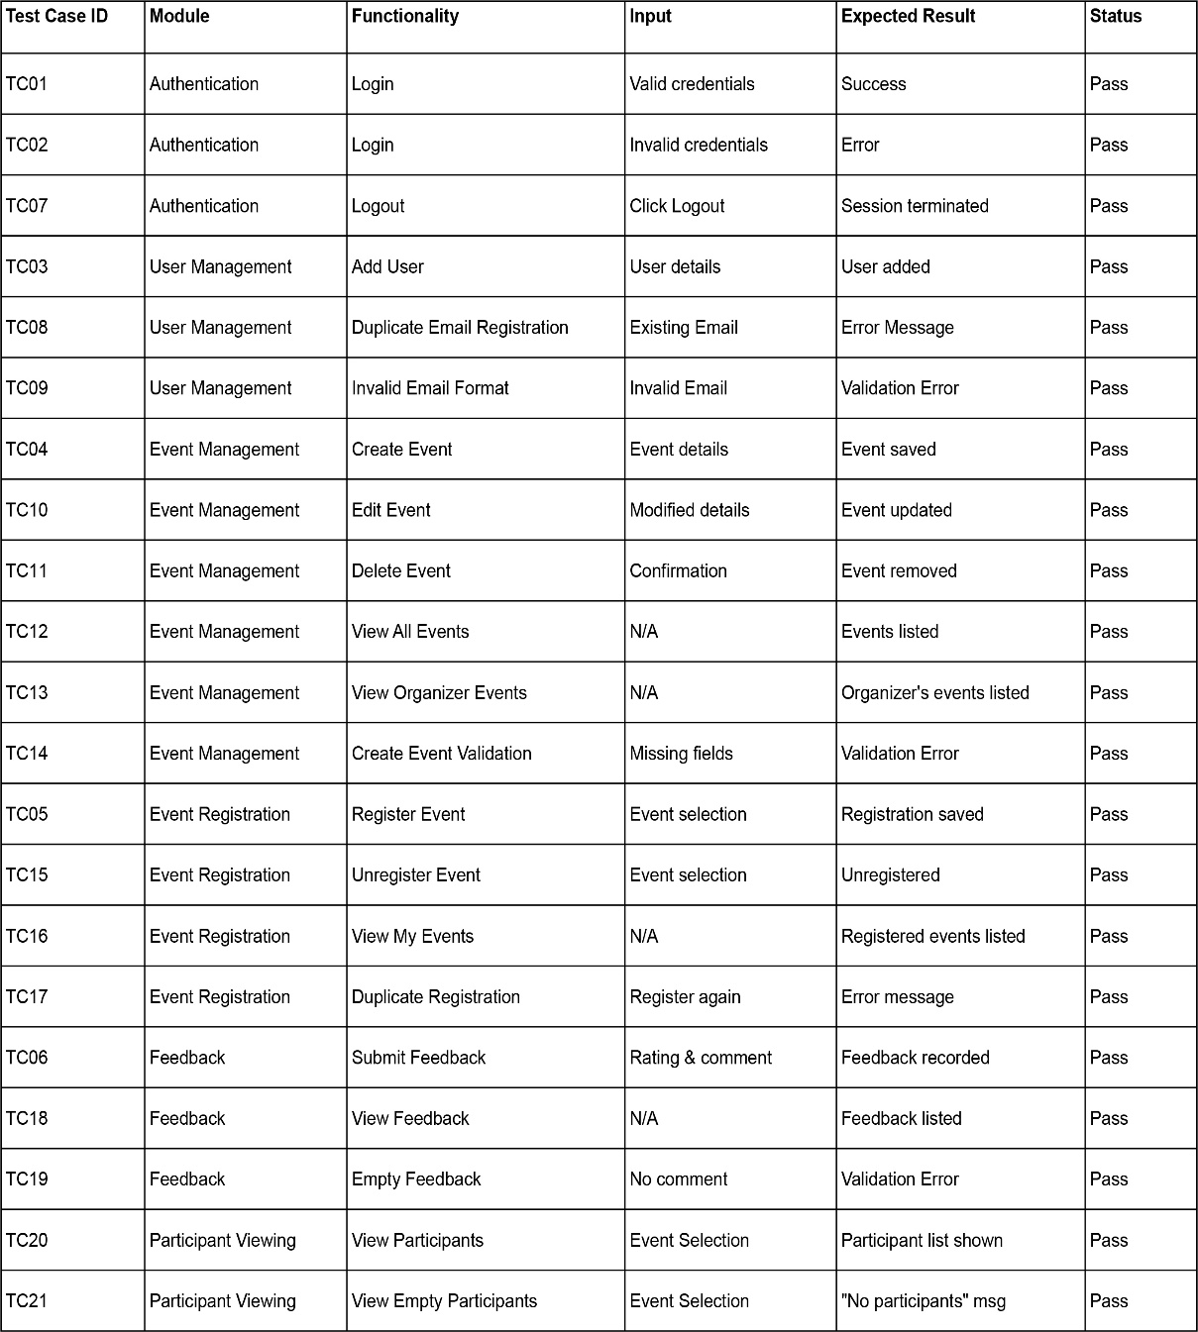
8. Conclusion
The CampusConnect project successfully delivers a functional and role-specific desktop platform for managing college events. Built using Java Swing for the user interface and SQLite for local data persistence, the application effectively addresses the core objectives of streamlining event creation, registration, and feedback processes within a college community. The implementation adheres to a layered architecture and SOLID design principles, establishing a maintainable and extensible codebase. Key achievements include the robust implementation of user authentication with role-based access control, comprehensive event management features for organizers (including creating, editing, deleting, and viewing participants),

